NAME: S. DHARANI
REG NO: 192472364
COURSE CODE: DSA0401
NUMPY / PANDAS ANALYSIS – QUESTIONS AND ANSWERS
QUESTION 16: WORD FREQUENCY IN CUSTOMER REVIEWS
AIM:
To calculate the frequency of words in a customer reviews dataset.
ALGORITHM:
1. Import Pandas, Counter and re.
2. Create or load the customer review data.
3. Convert reviews to lowercase.
4. Extract words and count their frequency.
5. Display the word counts.
CODE:
import pandas as pd
from collections import Counter
import re
df = pd.DataFrame({
"Review": ["Good product", "Good quality", "Useful product"]
})
text = " ".join(df["Review"]).lower()
words = re.findall(r"\b[a-z]+\b", text)
frequency = Counter(words)
for word, count in frequency.items():
print(word, ":", count)
INPUT:
Reviews: Good product; Good quality; Useful product
OUTPUT:
good : 2
product : 2
quality : 1
useful : 1
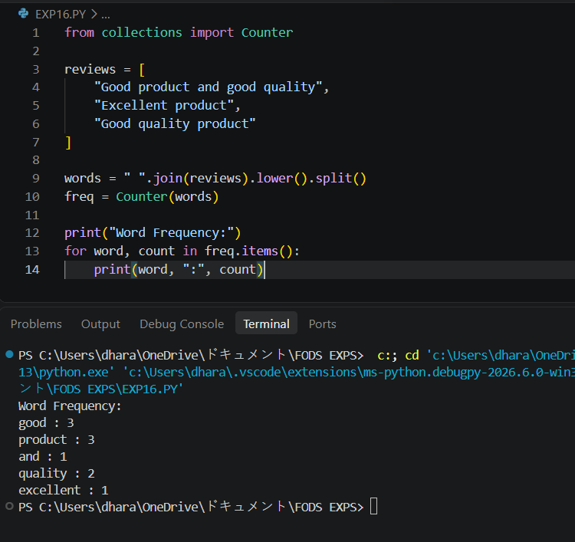
RESULT: Word frequency in customer reviews was calculated successfully.

